Lab 8 Assignment

Submitted by
Ravi Kiran Yadavalli -13
Ragunandan Rao Malangully -31

Task 1:
The task here was to perform sentiment analysis on Twitter streaming data. I performed the following steps to complete the task.
- Create Twitter stream using Twitter4j package.
- Filter the Tweets where the language is English.
- Extract only the Tweet text from the Tweet.
- For every Tweet text perform sentiment analysis using the Stanford NLP class.
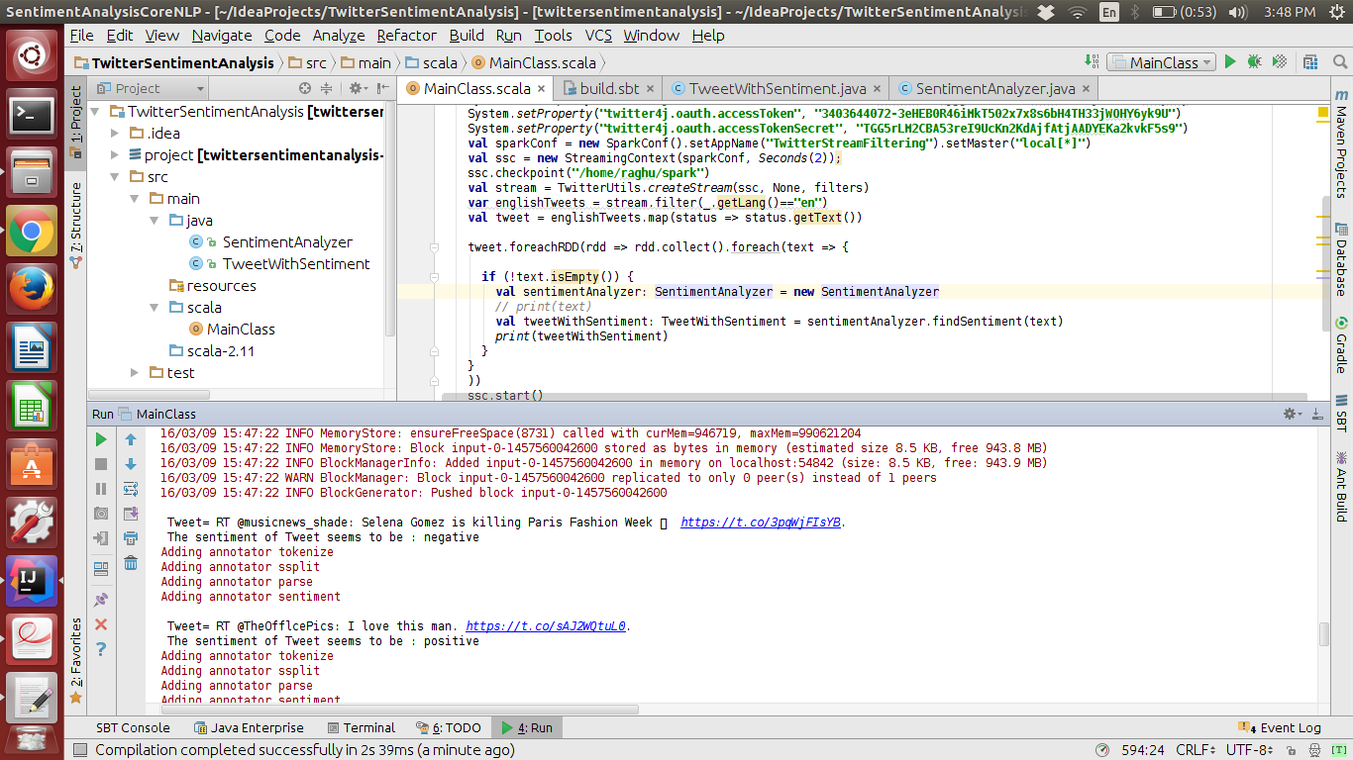
- Output the Tweet Text along with the sentiment of the Tweet text.

Task 2:
The task here was to create a recommendation system based on Twitter stream. For accomplishing this task the following steps were followd.
1. Create a Twitter Stream to stream Tweets and perform real time classification based on what categories they belonged to.
2. Then part of this data was used to train the same classification algorithm.
3. Live Tweets from Twitter stream was categorized using the classification alogirthm.
4. Then the data was stored as the format of userId:Tweet:Category:CategoryId.
5.This was used as a training data for the recommendation system.
6. Then recommendations were performed on the data.

